

Middle School
Lunch Menu
September 2023

MONDAY | TUESDAY | WEDNESDAY | THURSDAY | FRIDAY
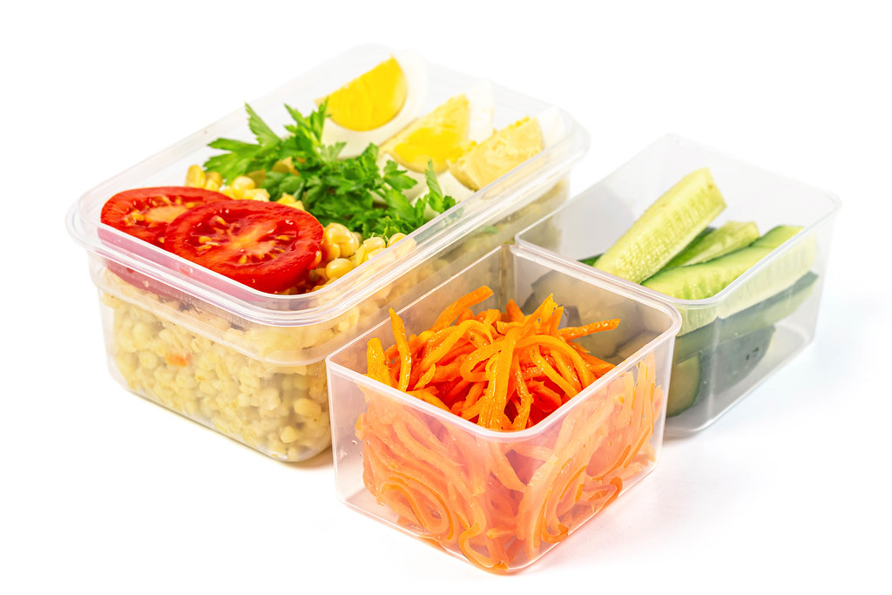 |  |  | 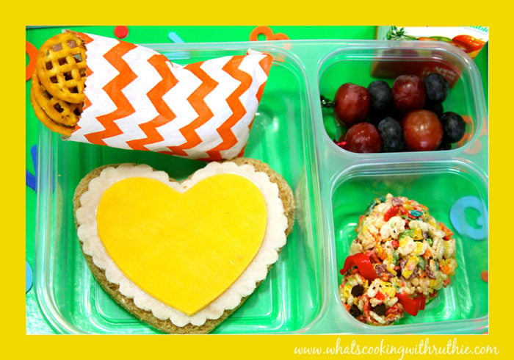 |  | More Info…  Offered Daily:  SANDWICHES  AND  HOAGIES  Turkey Hoagies  Italian Hoagies  Other Assorted Sandwiches/  Hoagies  Chicken Patty and/or Cheeseburger  Peanut Butter & Jelly/When Available  SALADS AND WRAPS  Chicken Caesar Salad  Rainbow Chopped Salad  Chicken Caesar Wrap  Buffalo Chicken Wrap  Assorted Milk:  1% White/Skim  Fat Free Chocolate  Fat Free Strawberry  Teacher’s Lunches:  $5.00/$5.50  on the service line.
 |  | 6  Burger & A Dog Seasoned Baked Fries  Baked Bean Supreme  Chilled Applesauce  Fresh Fruits & Veggies  Milk | 7  Buffalo Chicken Cheese Steak  Seasoned  Peas & Carrots  Celery Sticks w/ Dip  Chilled Pears  Fruits/Vegetables  Milk | 8  Pizza Party  Romaine  Boats w/ Croutons  Pepper Strips  Chilled Peaches  Fresh Fruits & Veggies  Craisins  Celery Sticks w/ Dip  Milk
11  Egg & Cheese on a  WG Croissant  Hashbrown Rounds/3  Broccoli Salad  Baked Apples  Chilled OJ  B  Chilled Pears  Bagged Carrots w/ Dip  Milk | 12  Hot & Honey Nachos  Fluffy Brown Rice Buttery Corn  Cucumber Slices  Chilled Pineapple  Fresh Fruits & Veggies | 13  Hot Ham & Cheese on a Pretzel Bun  Hearty Tomato Soup  Sweet Potato Fries  Chickpea Salad  Chilled Pears  Fresh Fruits & Veggies | 14  GO EAGLES  Hot Dogs/2  Seasoned Fries  Baked Bean Supreme  Smart Food Popcorn  Wear your Green Fresh Fruits & Veggies | 15  Our Own Buffalo Chicken Pizza  Assorted Pizza  Cran-Apple  Spinach Salad  Fresh Fruits & Veggies
18  Grilled Cheese  Hearty Tomato Soup  Celery Sticks w/Dip  Chilled Pears  Fresh Fruits & Veggies | 19  Taco Tuesday  Hard or Soft/2  Fluffy Brown Rice  Buttery Corn  Black Bean Salad  Chilled Pineapple | 20  Rotisserie Chicken w/ WG Biscuit  Mashed Sweet Potatoes  Seasoned  Peas & Carrots  Fresh Fruits & Veggies | 21  Pancakes/2  Turkey  Sausage Patties/2  Diced Hash  Brown Potatoes  Baked Apples | 22  Wild Mike’s Everything Dippers  w/ Marinara  Romaine Boats  w/ Croutons  Chilled Applesauce
25  Penne Alfredo  w/WG Biscuit  Italian Green Beans  Chilled Peaches  Fresh Fruits & Veggies | 26  Hot & Honey Nachos  Fluffy Brown Rice Buttery Corn  Black Bean & Corn Salad  Cucumber Slices  Chilled Pineapple | 27  Meatball Sub w/ Parmesan Cheese  Seasoned French Fries  Candied Carrots  Chilled Fruit Cocktail  Fresh Fruits & Veggies | 28  General’s TSO’s Chicken  Vegetable Fried Rice  Diane’s Roasted Broccoli  Mandarin Oranges | 29  Our Own Buffalo Chicken Pizza  Assorted Pizza  Cran-Apple  Spinach Salad  Chilled Pears

Washington Township Pre-School Lunch Menu
Meal Applications Now Available Online!  www.Payschoolscentral.com  WT Food Service Department 856-582-4010 | Menus are subject to change without notice.  *IW=Individually Wrapped

